- Parody can be political, musical, etc.
- Must be at least 2 minutes
- Groups cannot be more than four
- Must turn in a script for the group
- Script must be typed.
- ALL WORK IS DUE FRIDAY!!!
- MUST BE YOUR OWN WORK!!!

Example of Script:
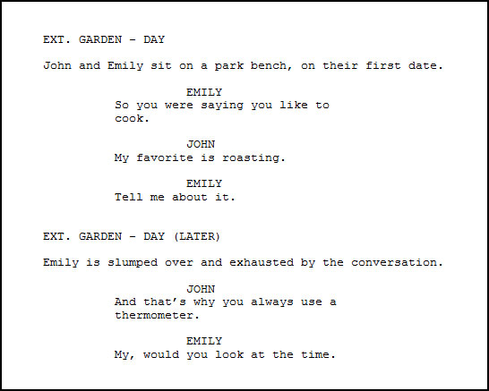
SCRIPTS MUST BE TURNED IN AT THE END OF THE PERIOD

